Y.M.C.A.COLLEGE OF PHYSICAL EDUCATION

A Christian Minority Institution

Nandanam, Chennai - 600 035.

Y M C A

R
INDIA

HARRY CROWE BUCK
FOUNDER
A Project of The National Council of YMCAs of India An Autonomous College, Registered under UGC act
Affiliated to Tamil Nadu Physical Education & Sports University Re-accredited by NAAC with 'A' Grade
Recognized by
National Council for Teacher Education & Government of Tamil Nadu www.ymcacollege.ac.in E-mail : admissions@ymcacollege.ac.in Contact No. : 044 - 2434 4816

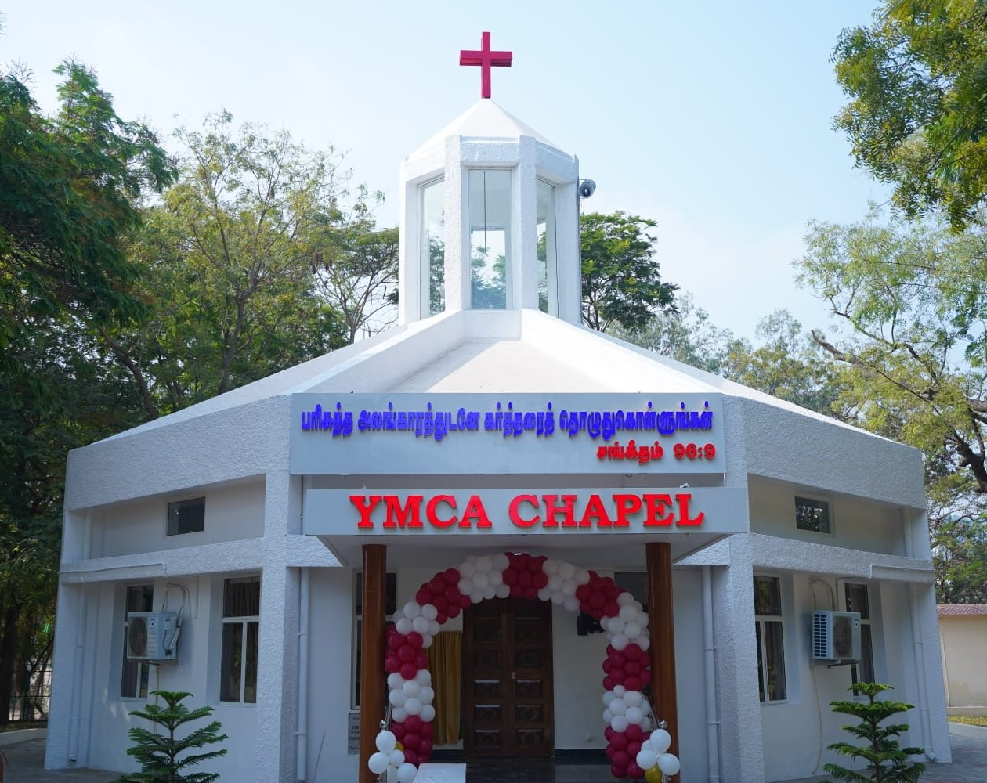
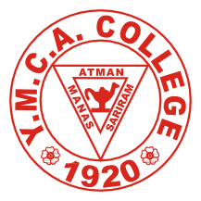

Application No.
PROSPECTUS 2025 - 2026

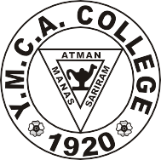
Y.M.C.A. COLLEGE OF PHYSICAL EDUCATION
R
Y M C A

A Christian Minority Institution

Nandanam, Chennai - 600 035.
A Project of The National Council of YMCAs of India An Autonomous College, Registered under UGC act
Affiliated to Tamil Nadu Physical Education & Sports University Re-accredited by NAAC with 'A' Grade
Recognized by
National Council for Teacher Education & Government of Tamil Nadu www.ymcacollege.ac.in E-mail : admissions@ymcacollege.ac.in Contact No. : 044 - 2434 4816

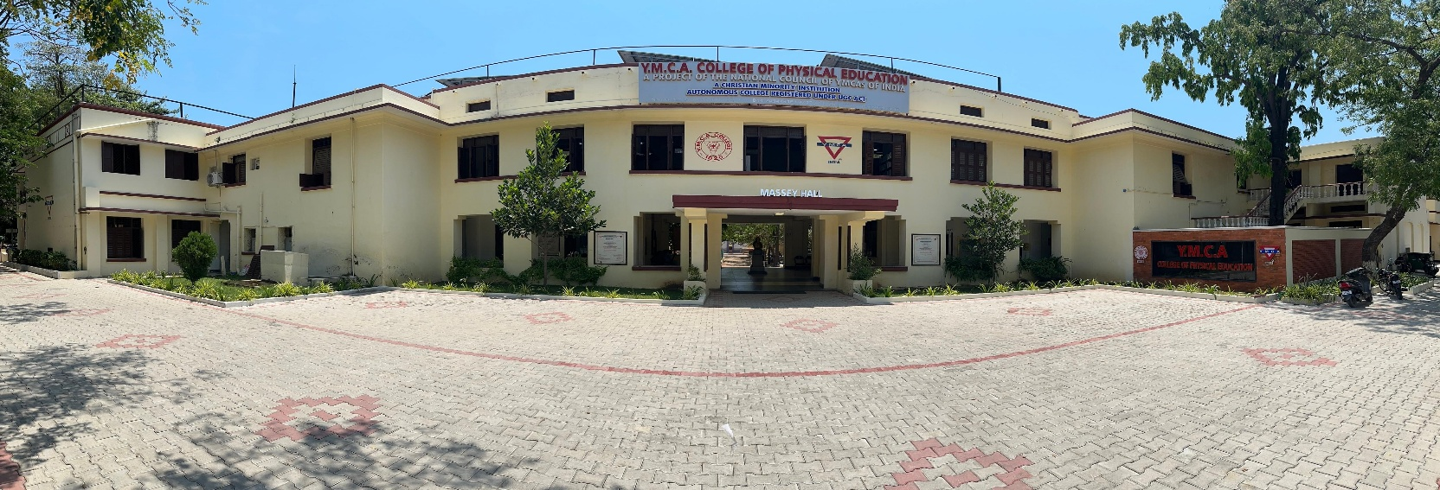

PROSPECTUS 2025 - 2026

INDIA

BRIEF HISTORY OF THE COLLEGE

The Y.M.C.A. College has a fascinating history. Realising the need for trained Physical Education, Sports and Recreation, a training centre
then known as the School of Physical Education was established in August, 1920 at the Central YMCA, Chennai. In 1924, the school was shifted to Royapettah YMCA where facilities for training were available. In 1932, the School was shifted to Saidapet. Here the School with many additional facilities became a full-
South East Asia.

Thousands of leaders in Physical Education from various states of India and countries like Burma, Nepal, Sri Lanka and even from far away countries like Egypt, Iran, Ghana and Mauritius have passed out of this college. From 1940, women are also being trained at the college.

Today the Y.M.C.A. College of Physical Education, as an autonomous college, stands as a monument to the missionary vision, courage and faith of its founder, Late Harry Crowe
to inspire all those who carry on the task of promoting Physical Education through this college which is reaccredited with 'A' Grade by NAAC, Recognised by National Council for Teacher Education (NCTE), Government of Tamil N

COURSES OFFERED AND ELIGIBILITY FOR ADMISSION

Government of Tamil Nadu and TNPESU Guidelines will be followed for Admission
The College offers the following courses of study for Men and Women.
- Ph.D. (Doctor of Philosophy in Physical Education) Full time and part time Eligibility is Master Degree in Physical Education (as per the norms of Tamil Nadu Physical Education and Sports University) [Admission Process Will be carried out by the TNPESU]

- M.P.Ed. (Master of Physical Education- Physical Education Teacher training Master degree course - Four Semesters) Applicant should have passed B.P.Ed. degree, obtained after a Bachelor's degree or its equivalent degree recognised by the Tamil Nadu Physical Education and Sports University (TNPESU) and should have required standard in atleast one major game or sport. Candidates with achievements in Sports and Games and professional training will be preferred. Admission is subject to eligibility rules of the Tamil Nadu Physical Education and Sports University, Tamil Nadu Government and NCTE.The candidate should not have Completed 35 years of age as on 1st July 2025.

- B.P.Ed. (Bachelor of Physical Education-Two years Physical Education Teacher training degree course - Four Semesters) Applicant should have passed in any degree (10+2+3 pattern) recognised by the TNPESU. Students who have obtained degree through Open University system are not eligible. Graduates from other than Tamil Nadu Physical Education and Sports University are eligible for admission only if their degrees

are accepted by the Tamil Nadu Physical Education and Sports University. Candidates who have obtained their degrees by private study must have their degree approved by the Tamil Nadu Physical Education and Sports University prior to the submission of application to the college. Applicant should have participated at least in inter- school or intercollegiate tournament in any sport/ game. The candidate should not have completed 30 years of age as on 1st July 2025. Relaxation on age may be 2 years for SC/ST and 6 years for ex-service men/ experienced Physical Education Teachers. BPE/ BPES / B.Sc (PHS) candidates will be given weightage in marks for selection.

- B.M.Sc. (Bachelor of Mobility Science - Two years Special Teacher Training degree course -Four Semesters) The Tamil Nadu Physical Education and Sports University has approved the Bachelor of Mobility Science for the Disabled. It was under Madras University since inception of the course i.e. 1989. Candidates with any Bachelor's degree recognized by the Tamil Nadu Physical Education and Sports University are eligible for admission. Students who have obtained degree through Open University system are not eligible. The candidate should not have completed 30 years of age as on 1st July 2025. Relaxation on age may be 2 years for SC/ST and 6 years for ex-service man/experienced Physical Education Teachers.

- B.P.E.S (Bachelor of Physical Education and Sports -Three Years Degree Course -Six Semesters): Applicant should have passed +2 exam of the Government of Tamil Nadu or any other equivalent examination, recognized by the Tamil Nadu Physical Education and Sports University and Tamil Nadu Government. Applicant should have participated atleast in interschool tournament in any sport / game. Age: The age limit for admission to the BPES degree course will be 21 years (Twenty one) as on 1st July 2025. For SC/SCA/ST/BC/BCM/DNC candidates age relaxation of 3 years beyond 21 years is permitted.

D.P.Ed. (Diploma in Physical Education - Two years non semester Physical Education Teacher training course under Govt. of Tamil Nadu) Eligibility as per Tamil Nadu Govt. Norms

: Candidates should have scored more than 50% of marks (600/1200 or 300/600 marks) in Higher Secondary Examinations.
  - SC/SCA/ST/BC/BCM/MBC - Minimum 45% of marks in Higher Secondary Education.
  - Candidates must have studied Tamil Language as Part I in Higher Secondary Course (+2).
  - Age: Candidates should not have completed 30 years of age as on 31.07.2025 for General Category. SC/SCA/ST candidates should not have completed 35 years of age as on 31.07.2025. Widows / Orphans should not have completed 40 years of age as on 31.07.2025.

Inter Caste marriage Candidates (BC / MBC) should not have completed 32 years of age as on 31.07.2025. Inter Caste Marriage candidates (SC/ST) should not have completed 37 years of age as on 31.07.2025). Candidates belonging to Tamil Nadu State alone will be admitted to D.P.Ed. Course.

COURSES OFFERED IN THE EVENING COLLEGE

The College offers the following courses of study for Men and Women in the Evening College

M.Sc., in Fitness, Exercise Rehabilitation and Nutritional Care. (FERNC)
This course is an ideal programme for Physiotherapists, Nutritionists, Physical Educationists, Occupational Therapists and Allied Health Science graduates. The multinational companies (Banks, Information Technology, Industries, etc.) are
s experts, gym instructors with knowledge in the area of nutrition in order to maximize the health and work capacity of their employees can make use of this special programme. This course also offers Yoga and Tai Chi as part of the training programme.

PG DIPLOMA IN SPORTS COACHING - TENNIS / CRICKET / SWIMMING
This is a one year non semester course. This course provides excellent opportunity for students to improve not only their playing ability in Tennis, Cricket & Swimming but also teaching and coaching skills.

COURSE OF STUDY | OPPORTUNITY / EMPLOYABILITY
Ph.D. | Asst. Professor / Director of Physical Education in University /  College
M.P.Ed. | Physical Director / P.E.T in Higher Secondary School
B.P.Ed. | Physical Director / P.E.T in Schools
B.M.Sc. | P.E.T in High School / P.E.T in Special School
D.P.Ed. | P.E.T in High School, Middle School and Primary School
B.P.E.S. | Can pursue B.P.Ed. Degree / Fitness & Personal Trainers
M.Sc. | Instructor in Fitness Centre / Gym / Rehabilitation Centre  /Physiotherapy Centre / Yoga Centre
P.G.Diploma | Fitness Trainers for the  Event Manager / Counsellor / Yoga Instructor

Physical Education and Sports University before seeking admission to any of the degree courses offered by the college. Any other
to the above will be considered only on condition that he/she gets
from the Tamil Nadu Physical Education and Sports University. The College reserves the

requirement of the Tamil Nadu Physical Education and Sports University / the Directorate of Government Examination. The College will not be held responsible for any consequential

damages in this issue. Candidates with doubtful qualification will not be admitted. Candidates admitted for training in the college are expected to follow the rules and regulations given in the college calendar and as amended from time to time by the college authorities. Candidates from other State Universities should obtain migration certificate from their respective universities. Students who withdraw before completion of the course should pay the full fee (except mess fees) before receiving their Transfer Certificate.
ADMISSION GUIDELINES 2025 - 2026
Admission to various courses of study will be done based on the guidelines of NCTE, Government of Tamil Nadu and TNPESU. The candidates are asked to attend the selection trials and interview without fail as per the notification given in the general instruction page. As per the guidelines of Government of Tamil Nadu vide Letter No”9768/DAP -3.1/2017-24, dated 10.05.2024 and TNPESU circular vide Lr.No.10 TNPESU/R3/Reservation /2024, dated 26-06-2024, a minimum reservation (not less than 5% seats) for individuals with benchmark disabilities. The selection will depend on the following criteria: Persons with Disabilities who can clearly communicate, demonstrate proficiency, and evaluate effectively. Specifically, individuals who are dwarfs, acid attack survivors, partially blind with the ability to read and write with aid or those with hearing impairments who use hearing aids will be given preference for all courses offered by Y.M.C.A. College of Physical Education/TNPESU.
Pregnant women are not eligible for admission to any of the courses of study offered at the college.

B.P.Ed. [Regular]
  - Eligibility for Admission to the course
    - Bachelor's degree in any discipline with 50% marks and having at least participation in the Intercollegiate / Inter-zonal / District / School competition in sports and games as recognized by the AIU / IOA/SGFV Govt. of India

(or)
    - Bachelor's degree in Physical Education with 45% marks.

(or)
    - Bachelor's degree in any discipline with 45% marks and studied Physical Education as compulsory/elective subject.

(or)
    - Bachelor's degree with 45% marks and having participated in National / Inter University/ State competition or secured 1st, 2nd or 3rd position in Intercollegiate / Inter -Zonal / District / School competition in sports and games as recognized by the AIU/IOA/SGF/ Govt. of India.

(or)
    - Bachelor's degree with participation in International competitions or secured 1st, 2nd or 3rd position in National / Inter -University competition in sports and games as recognized by respective federations/ AIU / IOA/SGFI/ Govt. of India.

(or)
    - Graduation with 45% marks and at least three years of teaching experience for deputed in – service candidates i.e. trained physical education teachers/ coaches.

Note: A candidate shall be eligible for admission to the Bachelor of Physical Education degree course (B.P.Ed) if he/she has received a degree in 10+2+3 pattern or any degree from a University recognized by Tamil Nadu Physical Education and Sports University.

A minimum inter-school participation in sports and games is compulsory.

  - The candidates should not have completed 30 years of age as on 1st July 2025. However a relaxation of 3 years shall be given for SC/ST candidates.
  - Ex-Servicemen /Experienced Physical Education Teachers shall be given relaxation of 6 years in age.

  - Pregnant women are not permitted either for admission or to undergo the course. If violated, they will not be permitted to continue the course.

Admission shall be made on the basis of ranking for a total of 150 marks as detailed below:
1. Qualifying Examination [Bonus marks for possession of basic degree in Physical Education (B.Sc Physical Education, Health Education and Sports or Bachelor of Physical Education (B.P.E) or Bachelor of Physical Education and Sports (B.P.E.S) or Diploma in Physical Education  (D.P.Ed)] | 25 marks
2. | 25 marks
3. Games and Sports (Skill test) | 50 marks
4. Physical Fitness Test [ 100 mts, Long Jump, Shot put ] | 50 marks
Total | 150 marks

Note :
Marks obtained in qualifying Degree shall be converted to a maximum of 20 marks. For example if a candidate secured 1800 marks out of 2400, his / her marks for qualifying examination is [1800 / 2400] x 20 = 15 marks.

Games and Sports Participation: (Maximum marks: 25)
The norms for award of marks for the sports and games participation are furnished hereunder. (Supporting cert

Any one which is applicable / advantageous.
1. Representing the Country | 25 Marks
2. - University competitions | 20 Marks
3. Representing State / University | 15 Marks
4. Representing District / Division | 10 Marks
5. Representing College / School | 05 Marks

Games and Sports Skill Test: Maximum Marks: 50
The candidate will be tested in any one of the games included in the All India Inter University (AIU) competitons.

Physical Fitness: Maximum Marks: 50
- 100 Mts. - 20 Marks
- Shot-Put - 15 Marks
- Long Jump - 15 Marks

Note: The games skill test and Physical Fitness tests will be conducted.

M.P.Ed. [Regular]
- ​Eligibility for Admission to the Course

  - Bachelor of Physical Education (B.P.Ed) or equivalent with at least 50% marks

Note:
A candidate shall be eligible for admission to the Master of Physical Education degree course (M.P.Ed) if he/she has received a degree in 10+2+3 pattern with B.P.Ed. degree pattern from a University recognised by Tamil Nadu Physical Education and Sports University.

  - A minimum intercollege level participation in sports and games is compulsory.
  - The candidates should not have completed 35 years of age as on 1st July 2025. However a relaxation of 3 years shall be given for SC/ST candidates.

  - Ex-Servicemen with B.P.Ed degree / Experienced Physical Education Teachers shall be given a relaxation of 6 years in age.

  - The candidate

  - Pregnant women are not permitted either for admission or to undergo the course. If violated, they will not be permitted to continue the course.
Admission shall be made on the basis of ranking for a total of 150 marks as detailed below:
1. Qualifying Examination | 25 marks
2. | 25 marks
3. Games and Sports (Skill test ) | 50 marks
4. Written Test | 35 marks
5. Personal Interview | 15 marks
Total | 150 marks

Note: Marks obtained in qualifying degree shall be converted to a maximum of 25 marks. For example if a candidate secured 1800 marks out of 2400, his / her marks for qualifying examinations is [1800 / 2400] x 25 = 18.75 marks.

Sports and Games Participation

The norms for the award of marks for the sports and games participation are furnished below: (Any one which is applicable / advantageous) submitted)
1. Representing the Country | 25 Marks
2. -University | 20 Marks
3. Representing the State/ university | 15 Marks
4. Representing the District/ division | 10 Marks
5. Representing the colleges | 05 Marks

Games and Sports skill test:
The candidates will be tested in any one of the following games and sports.
1. Track and Field | 2. Basketball | 3. Cricket
4. Football | 5. Hockey | 6. Handball
7. Volleyball

III. B.M.Sc. [Regular]
- B.P.Ed. Admission Procedure will be followed.
- Sponsored Candidates will be given Preference.

IV. B.P.E.S [Regular]
- Academic As given in Page No 3
- ​
B.P.Ed., degree will be followed for the B.P.E.S. degree candidates also.

V. D.P.Ed. [Regular]
- Academic As given in Page No.3
- Games skill Test: The candidates should choose any one of the game to undergo test in

- Physical Fitness Test: The candidates will be tested in the following events.
a)100 m | b) Shot put | C) 800 m

EVENING COLLEGE
- M.Sc. Degree (Fitness, Exercise, Rehabilitation and Nutritional Care) The applicants should have passed
1. BPT | 2. B.Sc., (Nutritional and Dietetics)
3. B.Sc., (Physical Education) | 4. B.P.E.S/ B.PE.
5. B.Sc., (Nursing) | 6. B.Sc. or its equivalent degree or any other degree as approved by the  University

PG DIPLOMA IN SPORTS COACHING - TENNIS / CRICKET / SWIMMING
Any under graduate degree, recognised and approved by the TNPESU Tennis / Cricket / Swimming

REGISTRATION OF APPLICATION
nline at http://www.ymcacollege.ac.in only.

The payment for online application fee Rs.48/- for UG course and Rs.58/- for PG course with a registration fee of Rs.2/- and Prospectus & selection trial fee of Rs.325/- which totals Rs.375/- for UG course and Rs.385/- for PG course should be paid through online while submitting your online application.

SC/ST/SCA/SCC (SC converted Christian) candidates of Tamil Nadu alone are eligible to avail only one online application at free of cost (the candidate need to pay the registration fee and selection trial fee which totals Rs.327/-for their second application)

Incomplete and ineligible applications will be rejected without any intimation.

During interview and Physical Fitness test the following certificates/details should be submitted
  - ​ General Education / Professional certificates.
  - ​ Proficiency certificates in games and sports.
  - ​
  - ​
  - ​ e Community certificate for BC/MBC/SC/SCC/ST candidates from a Deputy Thasildar /
Thasildar / Panchayat Union Commissioner.
  - EMIS Number for UG Candidates & UMIS Number for P.G Candidates.
  - Original Medical Fitness Certificate should be submitted during selection trial.

GENERAL INFORMATION
This college is residential for men and women students of Ph.D., M.P.Ed., B.P.Ed., B.M.Sc.,
B.P.E.S. and D.P.Ed., courses of study. Hence the students are expected to reside in the hostel during their course of study.

The selected candidates should submit the following certificates and details immediately to confirm
their seat and payment of first semester fees. (Re-opening /Reporting date 02nd July 2025)

1. General Education /Professional certificate. (SSLC, HSC, Degree certificate, B.P.Ed. Mark Statement)
2. Proficiency certificate in games and sports.
3. Age proof certificate. (Birth certificate or SSLC)
4.Transfer certificate, Course completion certificate, and Conduct certificate
5. Degree recognition certificate - applicable to candidates seeking admission to the degree courses from universities other than Tamil Nadu Physical Education and Sports University.
6.Migration certificate from candidates of other State and Union Territories
7. e-Community certificate issued during 2025 (for BC/MBC/SC/ST candidates) by a Thasildar / Dy. Thasildar / Panchayat Union Commissioner.
8. EMIS number for UG Students & UMIS Number for PG Students.
9. Aadhaar card – Photocopy
10. Bank pass book first page - Photocopy
11. Selected candidates should submit a certificate of undertaking by the parent [Prescribed format available in College website]
12. Original Medical certificate

PERSONAL EQUIPMENT: Selected students must equip themselves with the following personal equipment.
1. Good whistle  with chord | 2. Mosquito net | 3. Plate | 4. Tumbler
5. Mug | 6. Bucket | 7. Trunk box  with lock | 8. Stationaries
9.Bedding | 10.Shoes (Running & Formals) | 11.Attire for Practical & Theory Class | 12.Personal Playing equipment

INFORMATION TO THE SELECTED CANDIDATES
- Activity uniform will be provided by the college. Measurement for activity uniform will be taken by the college tailors, soon after the payment of fees for uniform.
- Men and women students will be provided with a blazer by the college. However they should have their own black pant and a white shirt (full-hand).
- Candidates who have passed the examination from other universities or bodies and awaiting the recognition of qualifying examinations should forward their applications through the PRINCIPAL of the college with the necessary certificates.

- M.P.Ed. candidates whose qualifying examinations obtained from other universities or bodies which have not yet been recognised by the TNPESU, should obtain clearance from the Tamil Nadu Physical Education and Sports University (TNPESU) before seeking admission in the college.

5. Grant of SC/ST Welfare Department Scholarship / Backward Classes Scholarship can be made only on maintenance of 90% attendance by the students concerned and no relaxation of this rule will be entertained.

- Admission is subject to the verification of Certificates by Director of Govt.Examinations/ TNPESU. If certificate is found to bogus, admission will be cancelled and criminal action will also be taken.

- Selected students should equip themselves with their own personal equipment for various activities.
- Transaction of any fee payment should be done only through DD or NEFT. No cash payment is entertained.
- Canvassing for admission in any form is prohibited and will be viewed seriously. Applications of such Candidates will be rejected.


